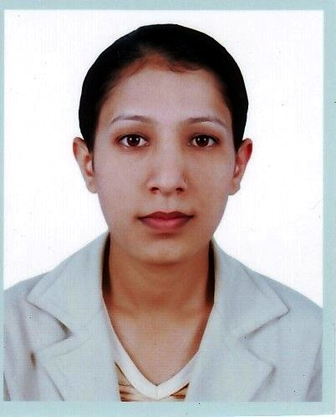

Curriculum Vitae
Binita Khadka

PERSONAL DETAILS

Name Binita Khadka
Contact Details Hadigaun, kathmandu
Tel: 9849142248; 9851032020
E-mail: Weeneetak.c@gmail.com
uginta_prithi@hotmail.com
Date of Birth June13 1985
Nationality Nepali
Sex Female
Marital Status Unmarried
Language Fluent in Nepali, English and fair Danuwari

EDUCATONAL QUALIFICATION

- L.L.B 2nd year running
- Master Of sociology , Trichandra collage ghantaghar 2nd year(thesis not submitted)(2010)

- Bachelor of Arts, T.U(2007)
- +2 of Major English , Shree higher secondary School dudhauli-8 sindhuli(2004)
- S.L.C Shree Bhagwati Secondary School Manebhangyang, Okhaldunga(2002)

PERSONAL EXPERIENCE

2011 June 15 till now Prime life insurance company Hattishar (Contract)
2007 –2010September Friends for Development Nepal, Programme Co-ordinator (Rautahat)
2003-2005 Lower Secondary Teachers

VOCATIONAL TRAINING

- Basic course from Himalayan computer Institute Samakhusi
- Photo Caning from Gillette Computer Institute Koteshwor
- Typing in Nepali & English Gorkhali Computer Institute Koteshwor

Duty and Job Responsibilities.
- Friendly Costumer service and hospitality.
- Daily Type & print, photocopy, Lamination.
- Cash Handing and cash Reconciliation
- Posses strong analytical and problem solving skills
- Can work under pressure
- Responsible for highly motivated trustworthy
- Excellent in Team works
- Good Communication Skills

All the information relating to my curriculum and other are absolutely correct and if any discrepancies are revealed I can be punished.

Reference:

Bhupendra khadka Laxman Regmi
9855068465 Secretary
Chairman Friends for Development nepal
Friends for development nepal Chandranigahpur-6 Rautahat
9745018422

